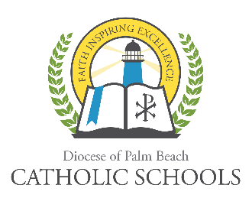
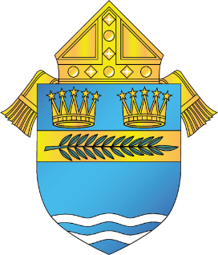

DIOCESE OF PALM BEACH
OFFICE OF CATHOLIC SCHOOLS NOTIFICATION

9995 N. Military Trail Telephone (561) 775-9500
Palm Beach Gardens, Florida 33410 www.DiocesePBSchools.org
DIOCESE OF PALM BEACH SCHOOLS WILL BEGIN VIRTUAL INSTRUCTION ON MARCH 31, 2020, WITH SCHOOL CAMPUSES CLOSED THROUGH APRIL 15, 2020
March 17, 2020
Dear Catholic School Administrators,

Please share the following announcement with your school community:

Most Reverend Gerald M. Barbarito, Bishop of Palm Beach, has closed the Catholic schools in the Diocese of Palm Beach through April 15, 2020. This does not apply to Rosarian Academy and Hope Rural School, which are private schools and will make their own determination. As previously announced, the diocese will commence with virtual instruction on March 31, 2020.

As additional details are available, they will be shared through your local Catholic school. This is an ever-evolving situation and the diocese will provide you with information as quickly as possible. During this development, and as always, the safety of the Diocese of Palm Beach faculty, staff, students and families are a top priority. Please visit our website www.diocesepbschools.org for the latest information.

The schools affected by this new protocol include:

Preschools
Holy Cross Preschool & Center
St. Thomas More Academy

High Schools
John Carroll High School
Cardinal Newman High School
St. John Paul II Academy

Elementary Schools
St. Helen Catholic School
St. Joseph Catholic School
St. Anastasia Catholic School
All Saints Catholic School
St. Clare Catholic School
St. Ann Catholic School
St. Juliana Catholic School
Sacred Heart Catholic School
St. Luke Catholic School
St. Vincent Ferrer Catholic School
St. Joan of Arc Catholic School
St. Jude Catholic School

